Bath Spa Counts, Staff and Student Diversity Data 2021/22
If you need Bath Spa Counts in a different format, please contact: the Equalities Officer Megan Robertson on m.robertson3@bathspa.ac.uk

1.0 What is Bath Spa Counts?
1.1 This booklet contains a snapshot of Bath Spa’s staff and student data for the academic year 2021/22. As well as some ‘Equality Highlights’ from this year (2022/23).
1.2 Staff data is taken from data supplied via MyHR. Comparator data is taken from the Higher Education Statistics Agency (HESA) and includes data from: Chichester, Falmouth, Gloucestershire, Goldsmiths, Lincoln, Oxford Brookes, and Winchester Universities. Sector data and student data is also taken from HESA.

Staff Data

2.0 Staff Gender
2.1 All Staff Gender
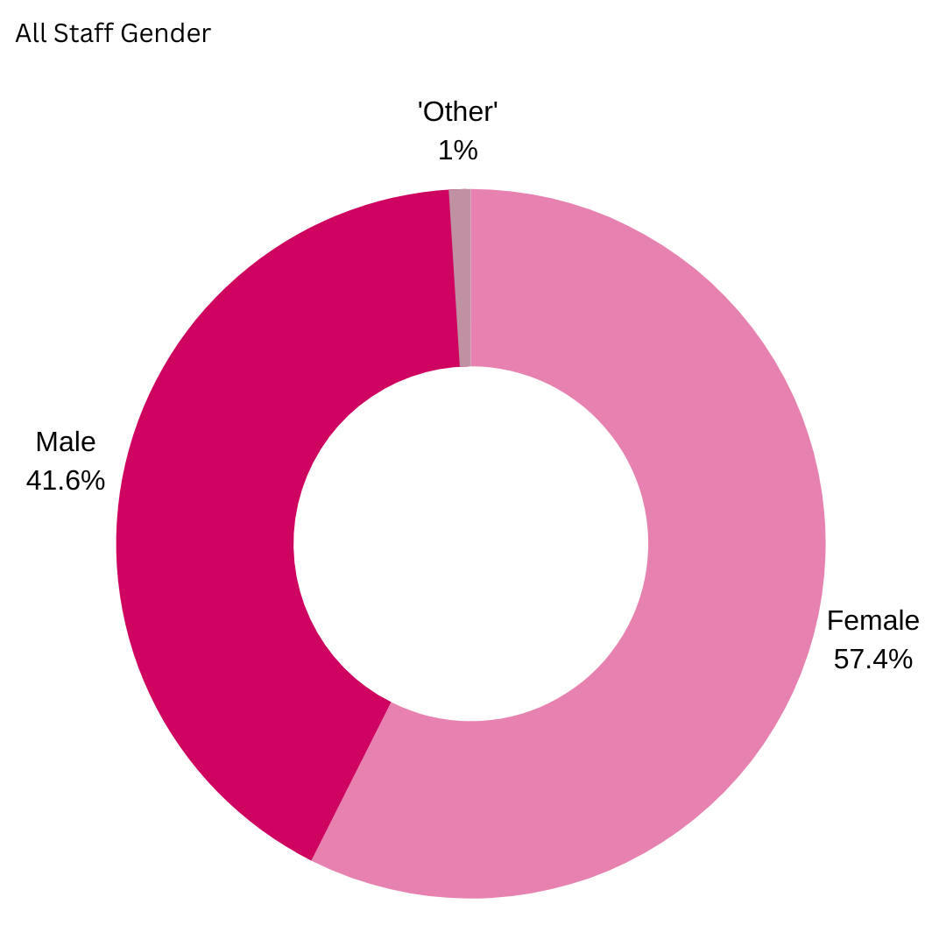
2.2 At Bath Spa in the year 2021/22, 57.6% of our staff identify as female, 41.7% identify as male and 1.0% identify as ‘other’. Which is aligned to the BSU comparator groups.

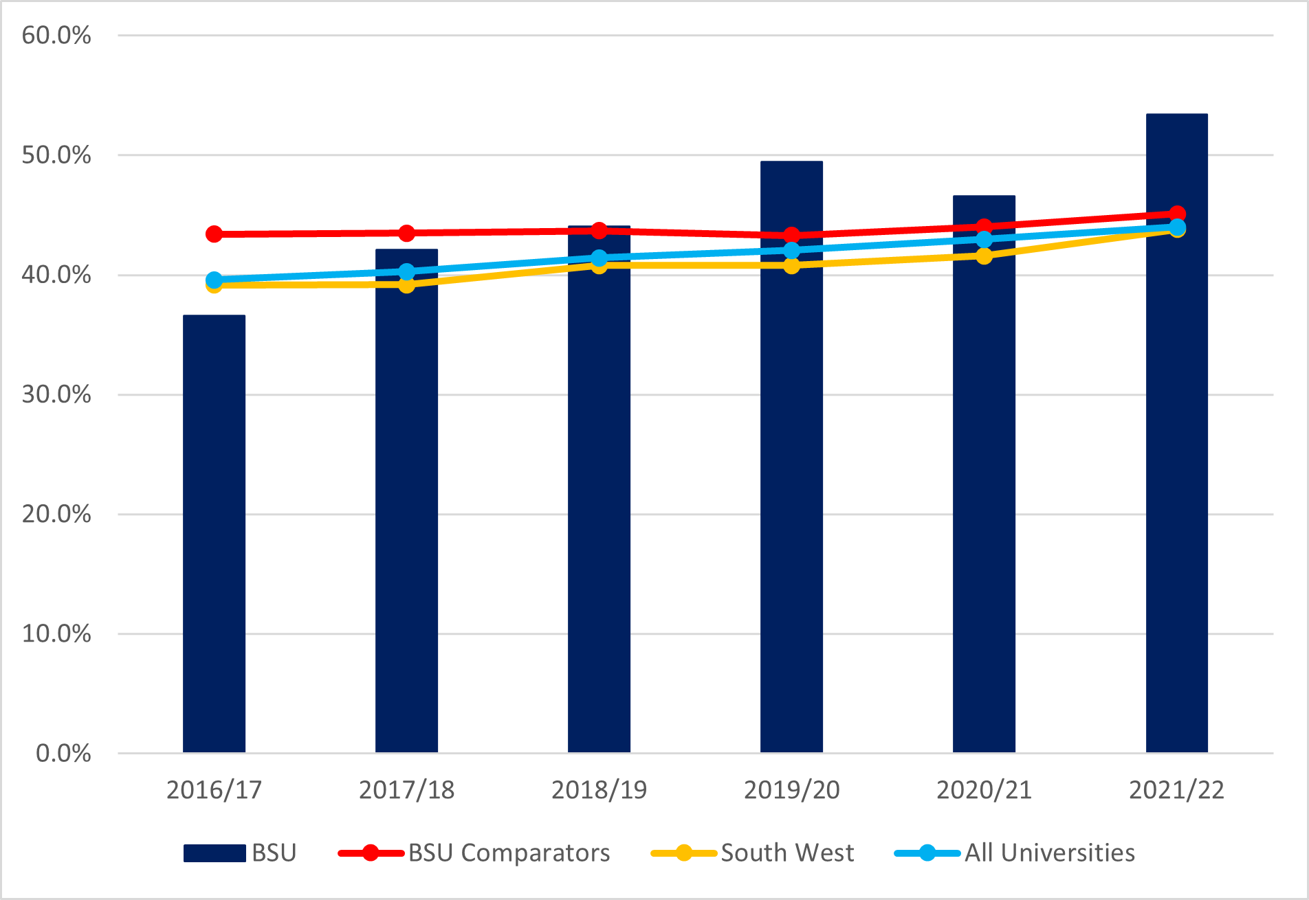
2.3 This year our Senior Staff that identify as female has increased to 53.4%, which is an increase from last year and above all our benchmarks.
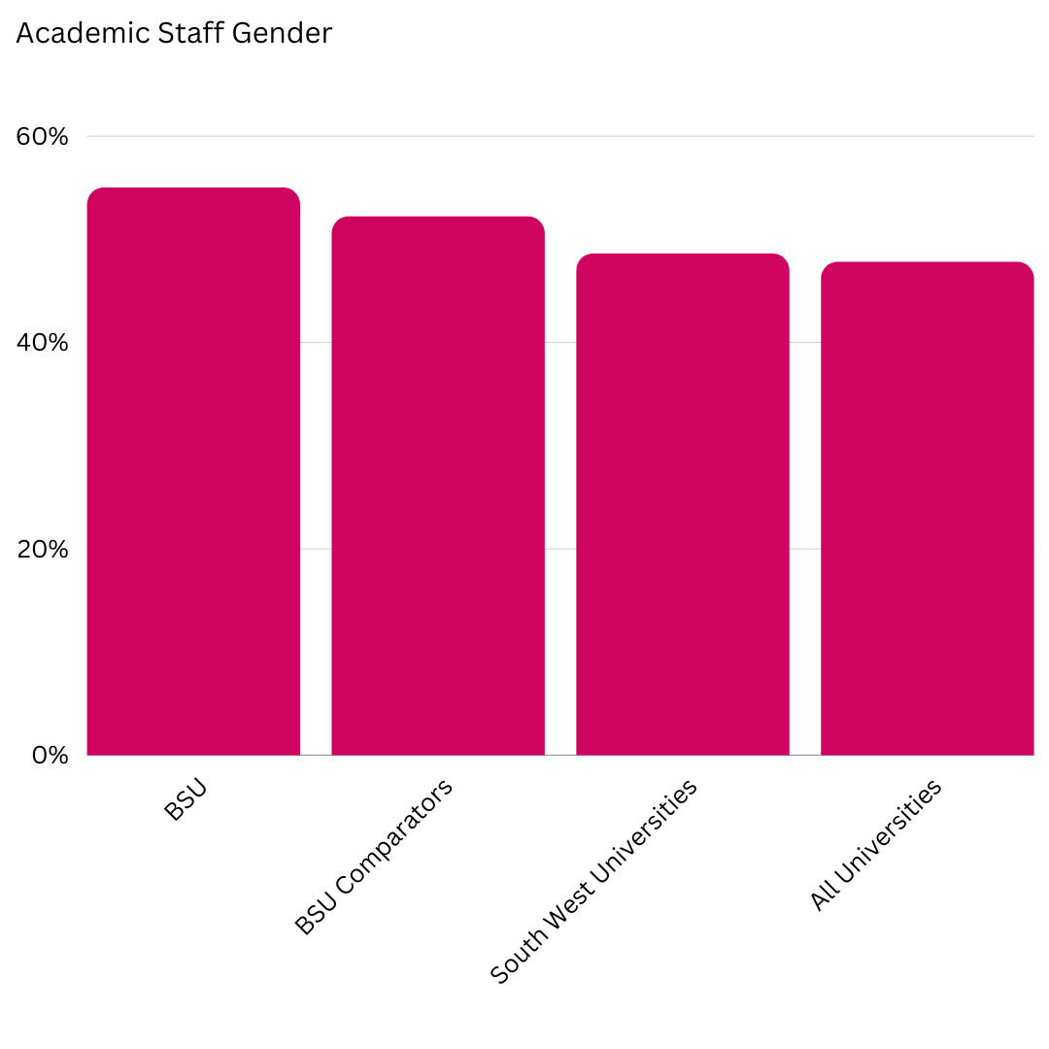
2.4 Out of our academic staff 55% identify as women. Which is above all our comparators. 52.2% at our BSU comparators identify as women, 48.6% at the South West Universities and 47.8% at all Universities.

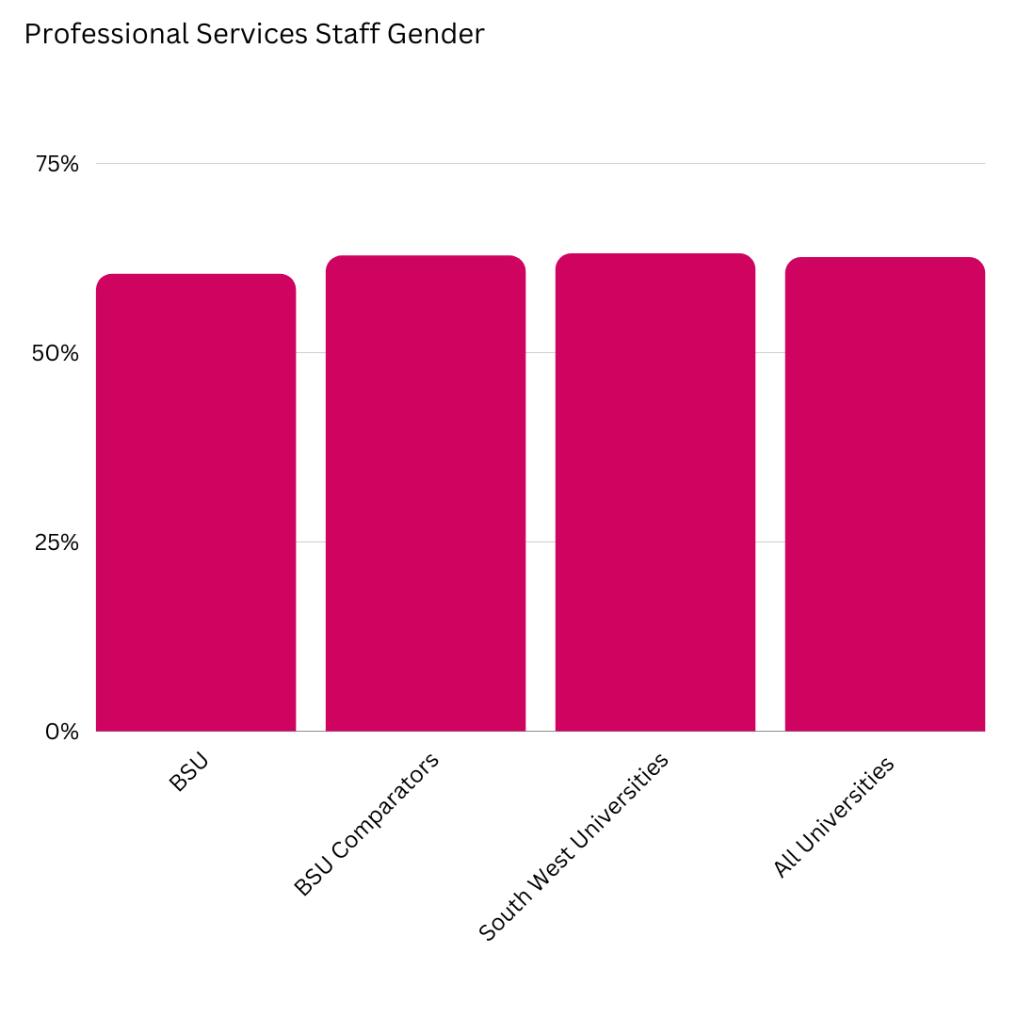
2.5 As for our BSU Professional Service staff 60.4% identify as women, which puts us in a very similar position to our comparators. 62.8% of our BSU Comparator identify as women, 63.1% at South West Universities identify as women and 62.6% of All Universities identify as women.

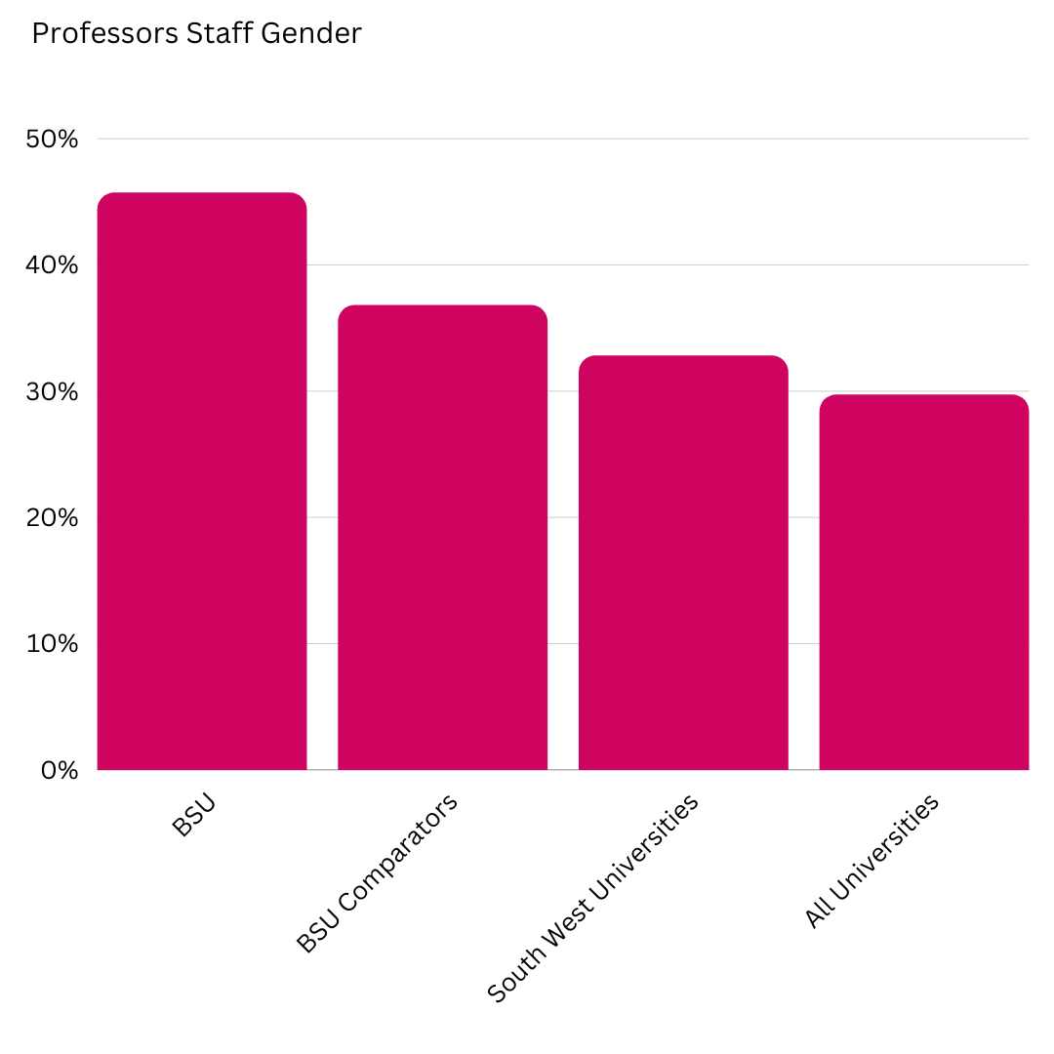
2.6 This year, 45.7% of professors identify as women, which is a 4.3% drop from last year. We are still high above our comparator groups with our 36.8% of BSU comparators identifying as women, 32.8% of our South West comparators identifying as women and 29.7% of All Universities identifying as women.

3.0 Gender Pay Gap 2022
3.1 Our mean pay gap this year is 11.0% which is equivalent to £2.24 per hour.
3.2 Our median pay gap this year is 11.0% which is equivalent to £2.22 per hour.

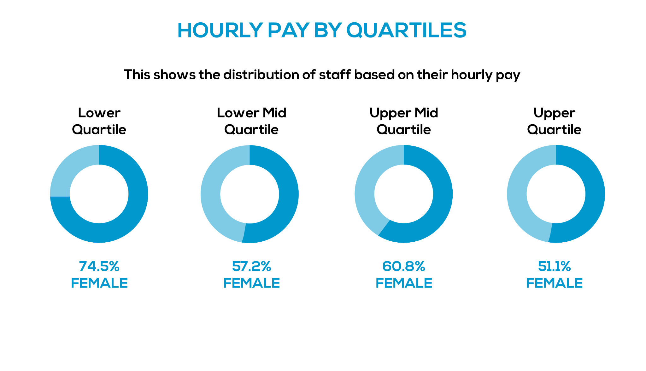

4.0 Staff Ethnicity Data
4.1 There is widespread criticism of the usage of ‘BAME’, one of the reasons being that it can obscure challenges concerning the representation of specific groups, such as the sector-wide underrepresentation of Black staff. We will use this abbreviated term for this report because of the way the data is presented. We have had discussions with our Global Inclusivity Network (GIN), and aim to look at a different term in the future.
4.2 Staff who identified as Black, Asian, or another minoritised ethnicity (abbreviated to BAME for this report) increased to 8.0%. The BSU comparator group is 15.1%, South West universities at 11.4%, and All Universities at 16.1%.
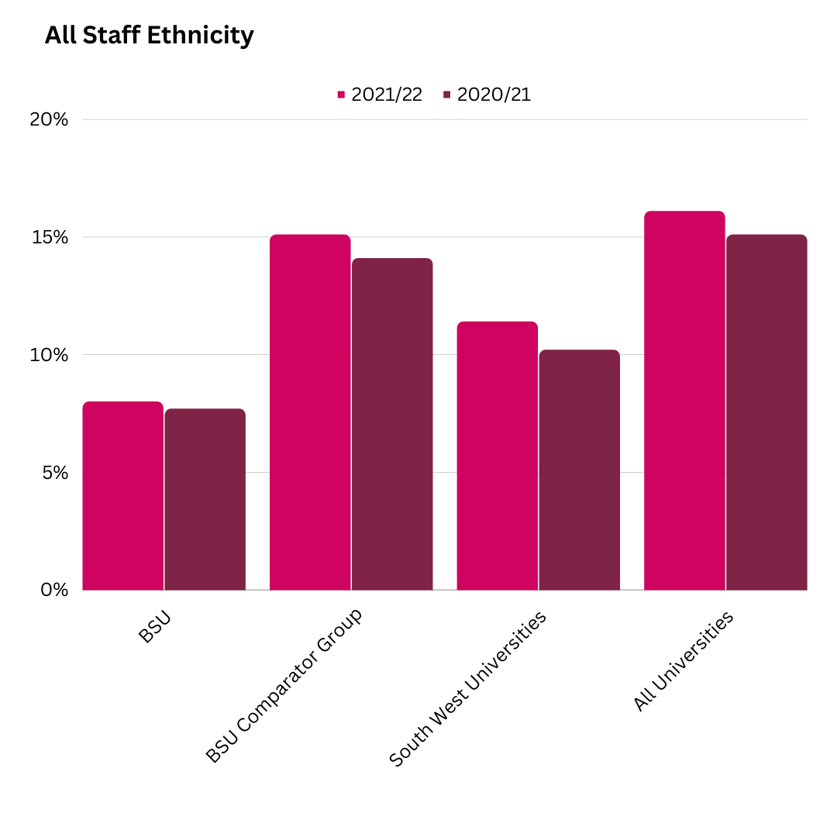

4.3 Within our Academic Staff force 10.4% identify as BAME. Although we are still below our comparators this increase has brought us closer to them, with the BSU comparator group and South West Universities both at 14.7%, and all Universities at 18.5%.
4.4 5.4% of our Professional Service staff identify as BAME. Our comparators are at 15.7%, South West Universities at 7.5% and All universities at 13.2%.

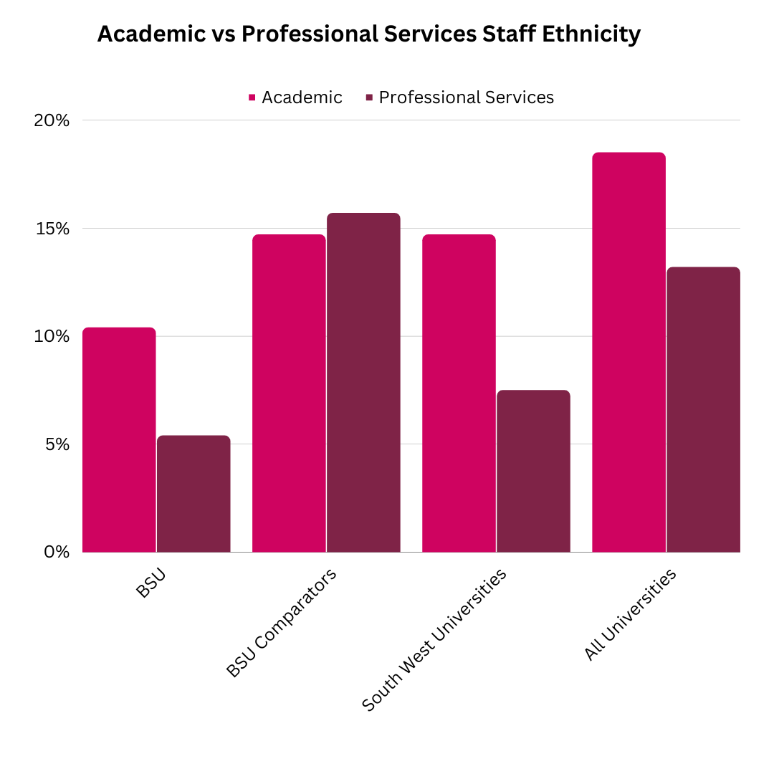

4.5 The most promising set of data is for our senior staff with 10.5% identifying as BAME which positions us higher than all our comparator groups BSU Comparators at 8.9%, South West Universities 6.9% and All Universities 7.9%.
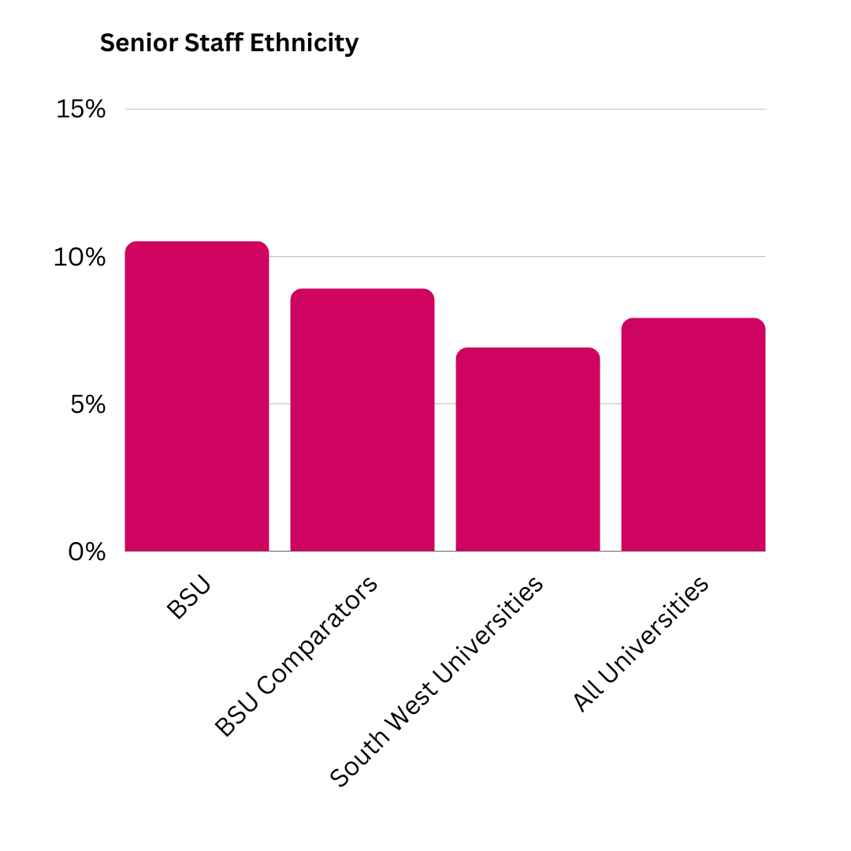

5.0 Disability
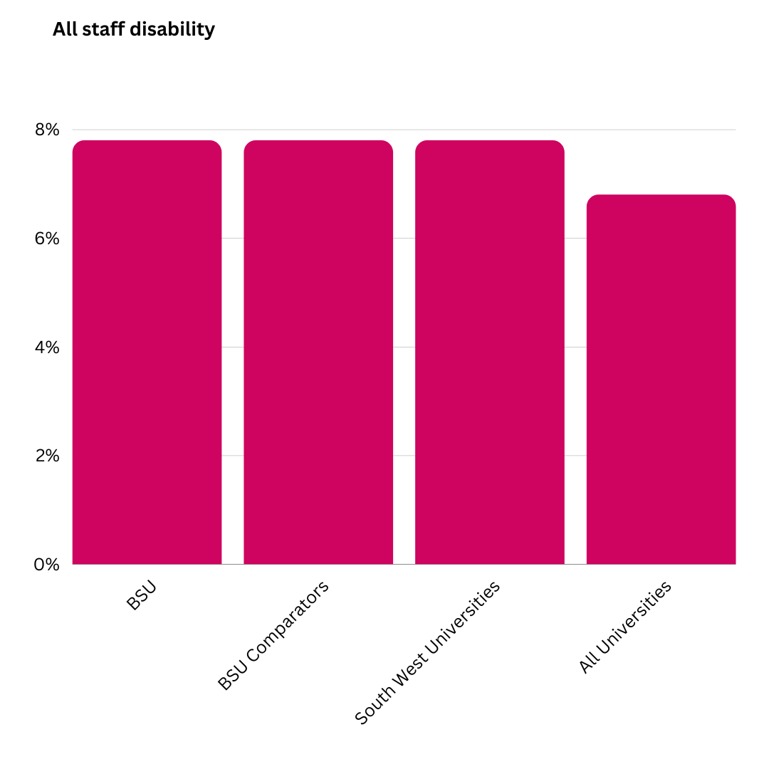
5.1 7.8% of our staff have identified as having a disability. Our BSU Comparators and South West Universities are also at 7.8% and All Universities at 6.8%.

6.2 5.6% of our Academic staff identify as having a disability, which is below our comparators, 7.2% of our comparator group identify as disabled, 6.4% of South West Universities identify as disabled and 6.0% of All Universities identify as disabled.
6.3 10.3% of Professional Services staff identify as disabled, 9.0% of our BSU Comparators, 9.2% of South West universities and 7.9% of All Universities identify as disabled.

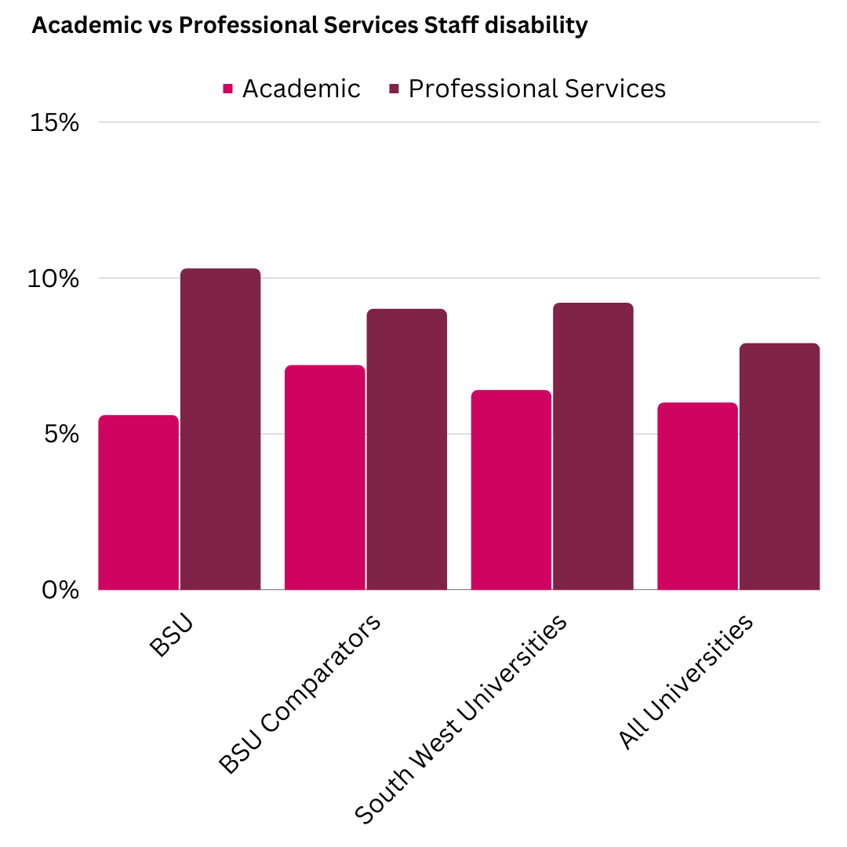

6.4 Senior Staff who declare that they have a disability is 3.0%. Compared to our comparators, BSU Comparators are at 3.5%, South West Universities at 4.5% and All Universities at 4.5%.
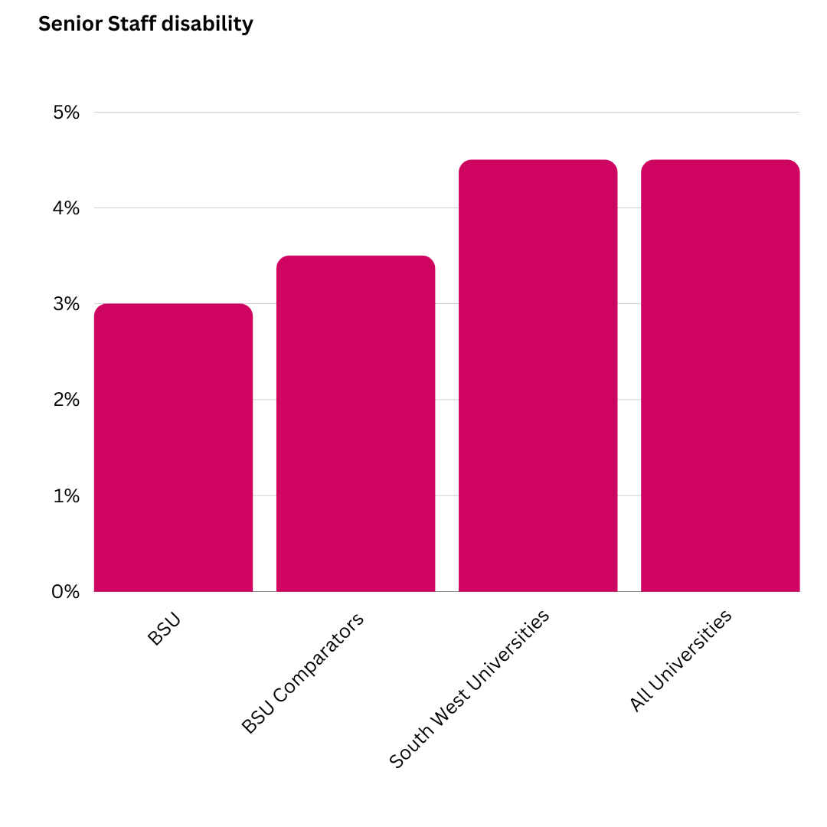

7.0 Age
7.1 The percentage of Bath Spa University staff aged: 40 and under is generally lower than our benchmarks. With only 7.7% aged between 26-30

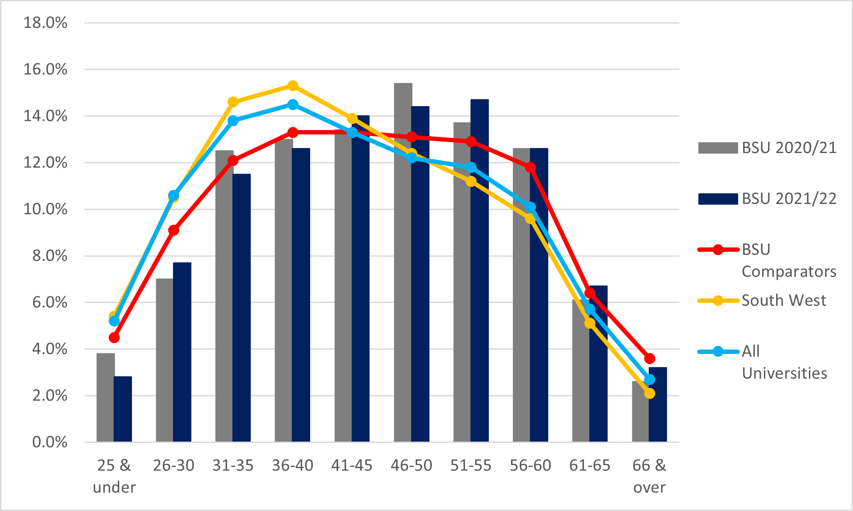

7.2 The proportion of staff aged between 46-50 is higher than our benchmarks at 14.4%
7.3 This year the age of senior staff between the 26-30 age bracket has increased to 1.5% which is a significant rise compared to our comparators, however, due to small numbers this is likely to be one person. With our BSU comparator at 0.0%, South West Universities at 0.4% and all Universities at 0.3%.
7.4 There has also been an increase of senior staff within the 41-45 bracket to 20%, which is above our comparator with BSU Comparators at 12.7%, South West Universities at 17.7% and All Universities at 13.2%.

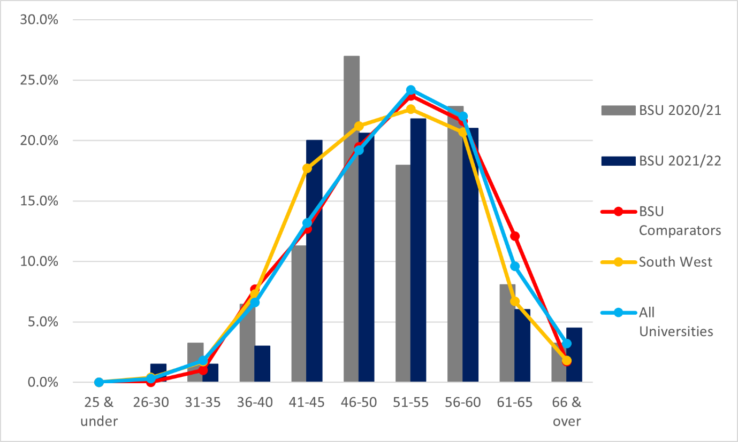
7.5 Academic Age: Our age composition of BSU Academics has remained the same as in previous years. With most of our academic staff being between 41-45 and our lowest 25 and younger.

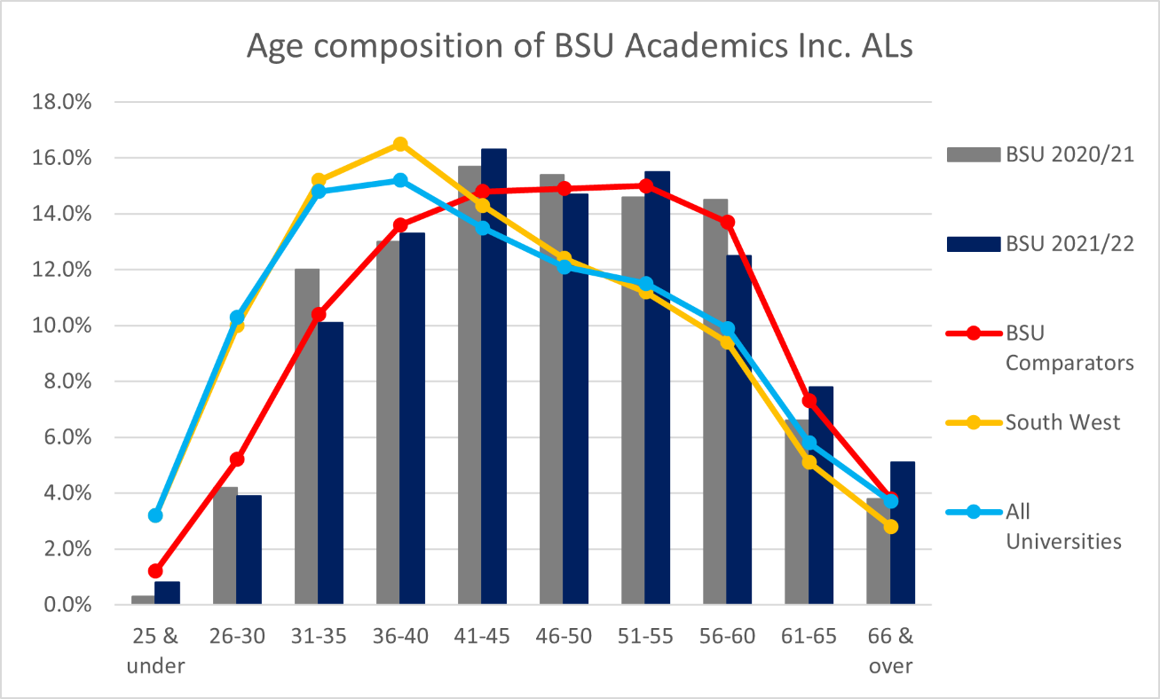

7.6 Professional Services: being very similar as our academic staff with a bigger jump in our 25 and under and 26-30 age bracket. We are very similar to all our comparator groups within professional services too. 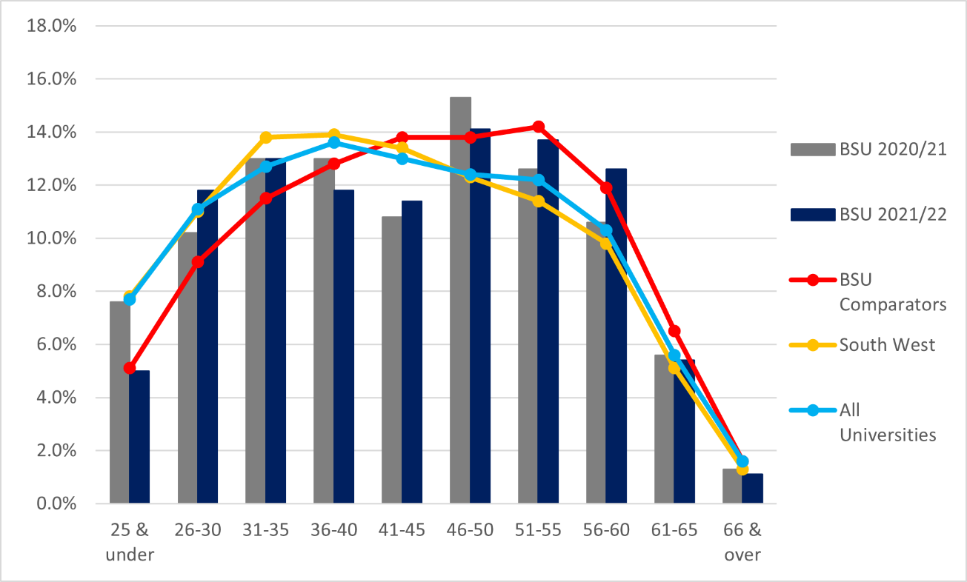

8.0 Sexual Orientation
8.1 5.6% off staff have reported their sexuality to be Lesbian, Gay, Bisexual or ‘other’ (abbreviated to LGB). Our BSU comparator group (from last year’s data set) is at 5.5%, South West Universities 2.5% and All Universities 3.7%.
8.2 Bath Spa Universities' non-disclosure rate is 20.3%. This means that the actual numbers of our staff's sexual orientation may not be a true representation.
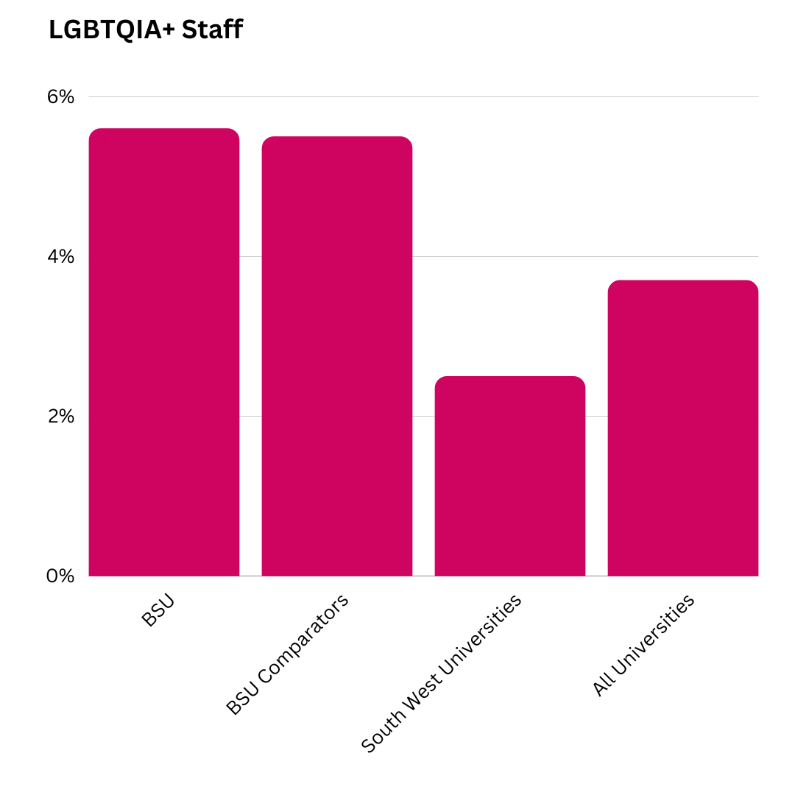

9.0 Religion
9.1 23.3% of staff identify as Christian, 6.9% of staff identify with other religions and 49.2% of staff identify with no religion.
9.2 Last year’s bath spa comparator group was 23.2% and 7.1%, South West universities at 11.7% and 3.1% and All Universities at 12.6% and 6.2%.
9.3 The proportion of staff who have decided not to disclose their religion is 20.7%. This means, as with sexual orientation, that the actual numbers may not be a true representation.

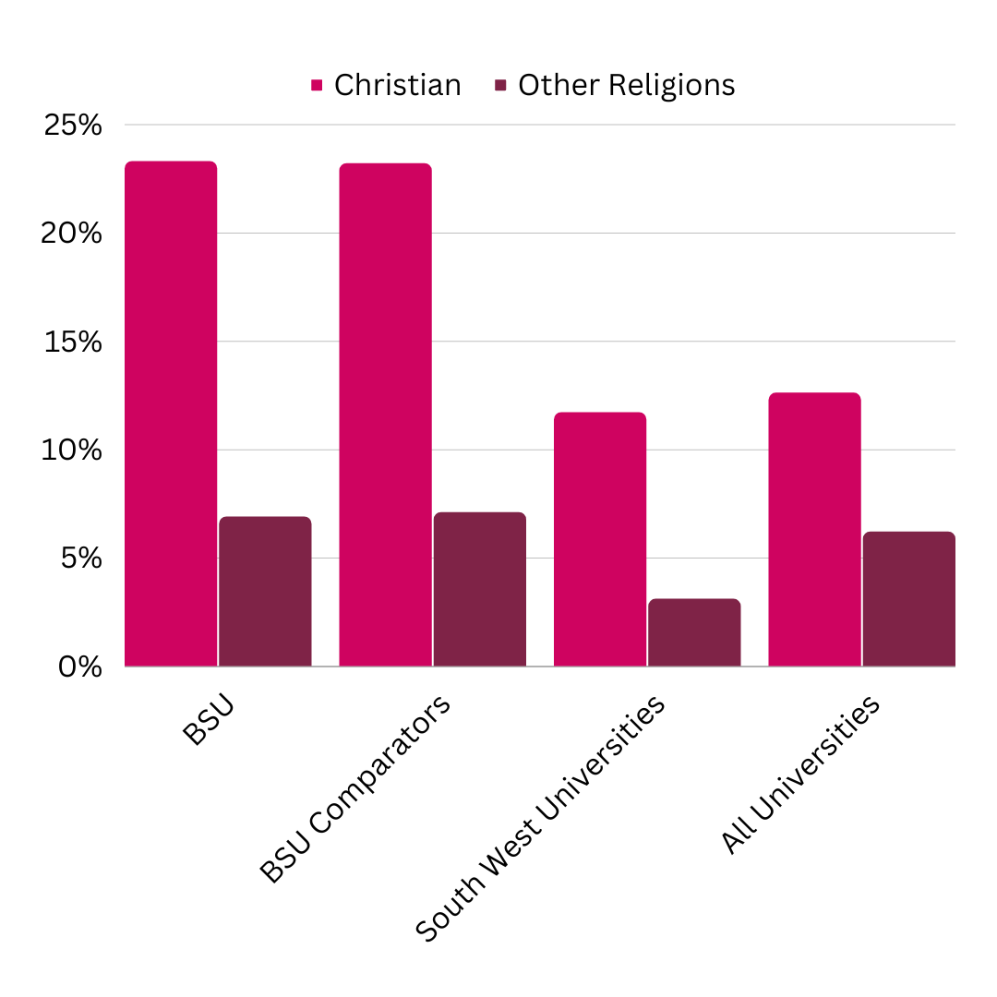

Student Data

1.0 Student Gender
1.1 66.9% of our students identify as female, with 32.8% identifying as male, and 0.3% identifying as ‘other’
1.2 57% of all Universities identify as female, 43% male and 0% ‘other’. Within our BSU Comparator group, 60.31% of students identify as female, 39.06% as male and 0.06% identify as ‘other’.
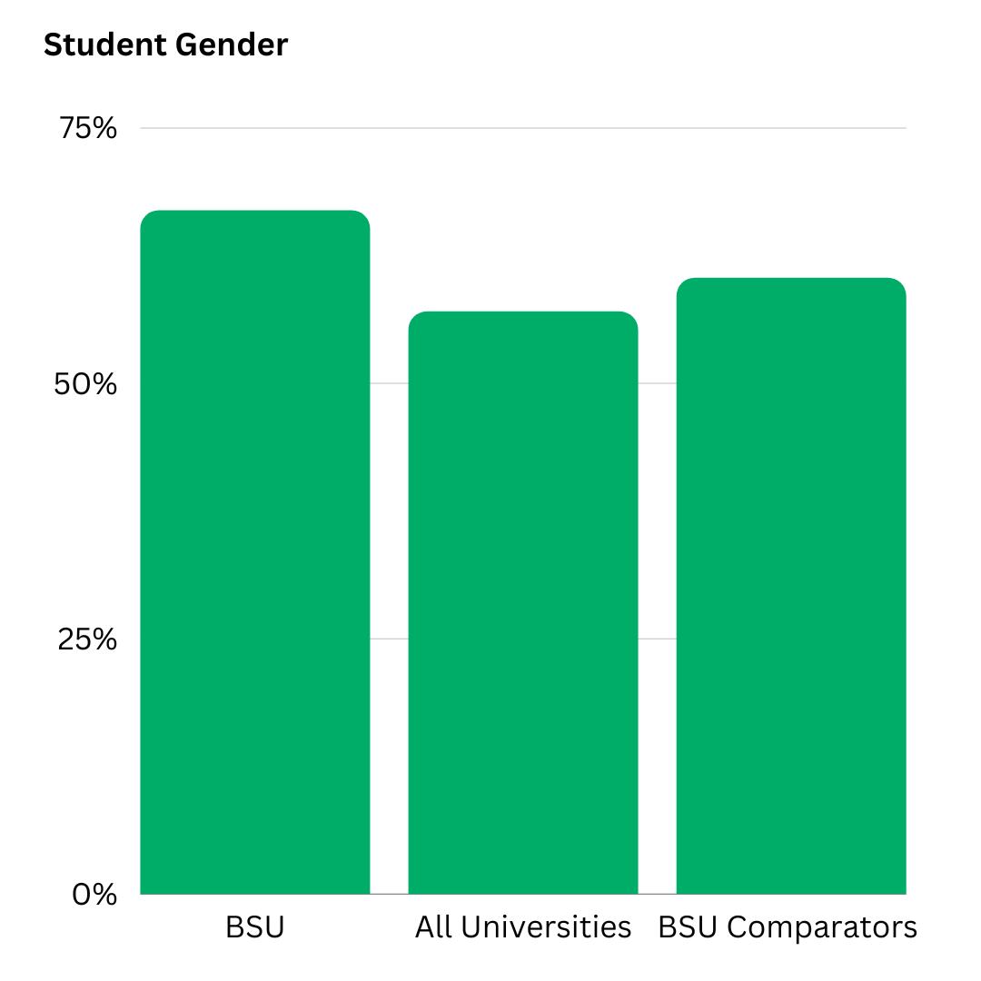

2.0 Student Disability
2.1 27.8% of our students have said that they have one or more known disabilities. And 72.2% have said that they have no known disabilities.
2.2 16% of all university students have said they have one of more known disabilities and 84% of all HEI’s have no known disabilities. Within our BSU Comparator group, 24.82% of students say they have one of more known disabilities and 75.19% say they have no known disability.

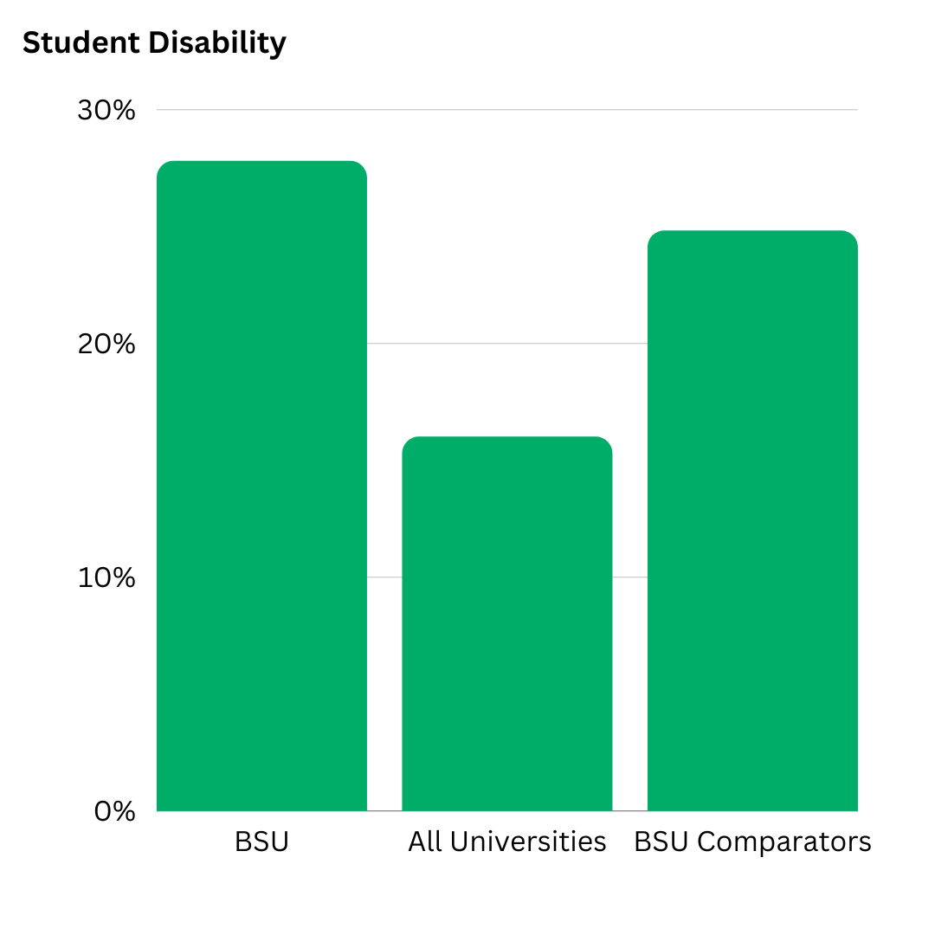

3.0 Sexual Orientation
3.1 16.1% of our students identify as LGBTQIA+, with 73.5% identifying as heterosexual and 10.5% prefer not to say.
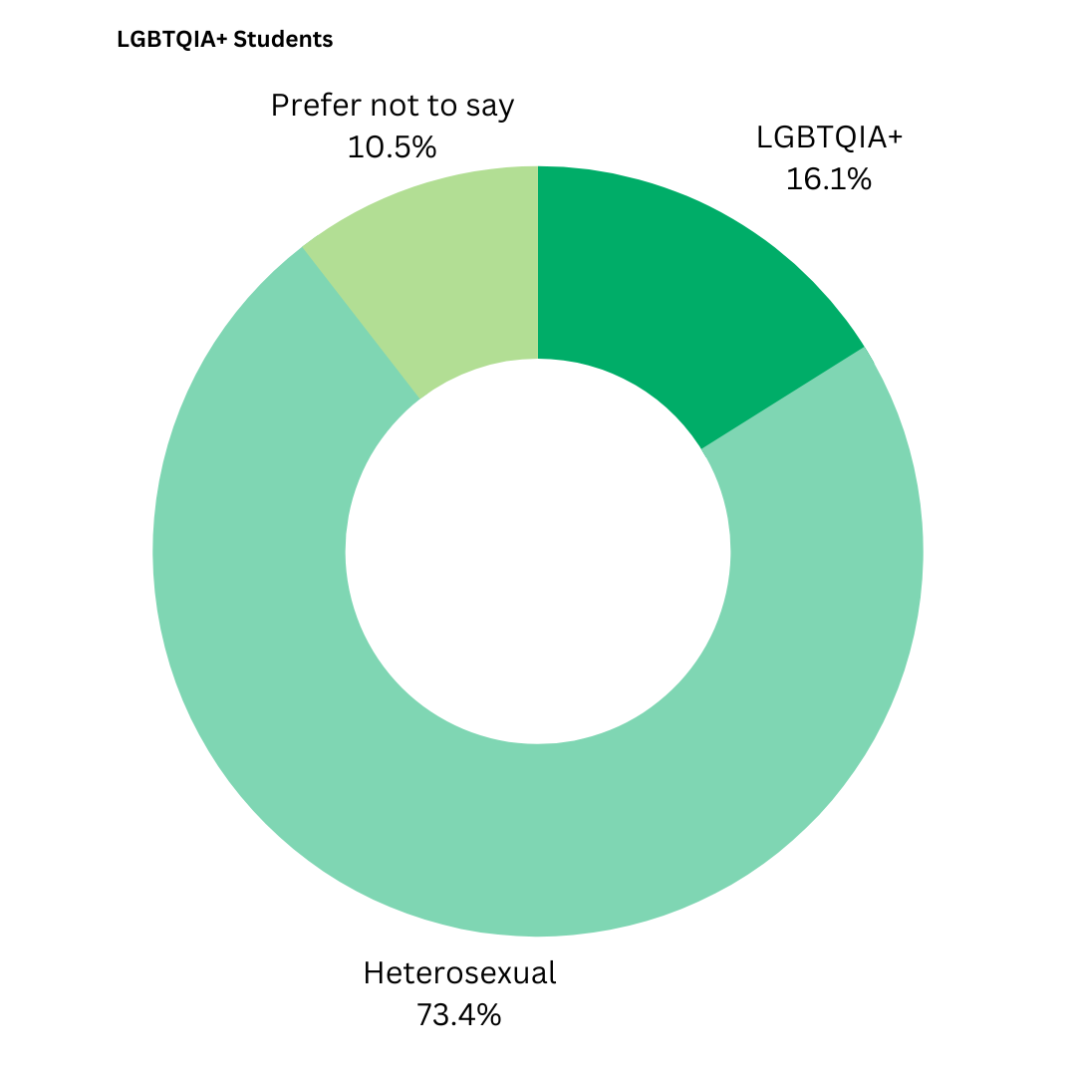

4.0 Religion
4.1 Below shows the religious groups that our represented within our student population.

No Religion 54.3%
Christian 27.2%
Muslim 3.8%
Prefer not to say 4.2%
Not Known 3.5%
Any other religion or belief 7%

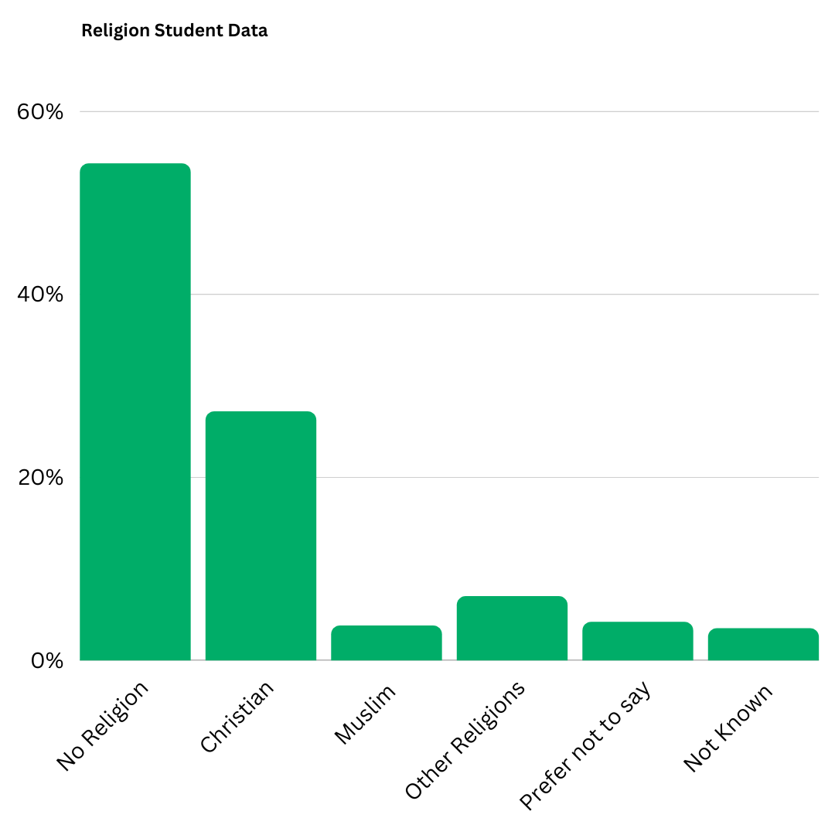

5.0 Ethnicity
5.1 At BSU the breakdown of ethnicity is below.

White: 82.6%
Black: 3%
Asian: 6.9%
Mixed Ethnicity: 4.3%
Information unknown: 0.9%

This means the amount of ‘BAME’ students we have at Bath Spa University is 14.2%

5.2 All HEI’s ethnicity is below.

White 73%
Black 8%
Asian 12%
Mixed 5%
Other 2%

This means the amount of ‘BAME’ students other HEI’s is 27%

5.3 And Our BSU comparator group is as follows:

White 87.10%
Black 3.35%
Asian 4.13%
Mixed 3.62%
Other 0.82%

This means the amount of ‘BAME’ students at our BSU comparator Group is BAME 11.92%
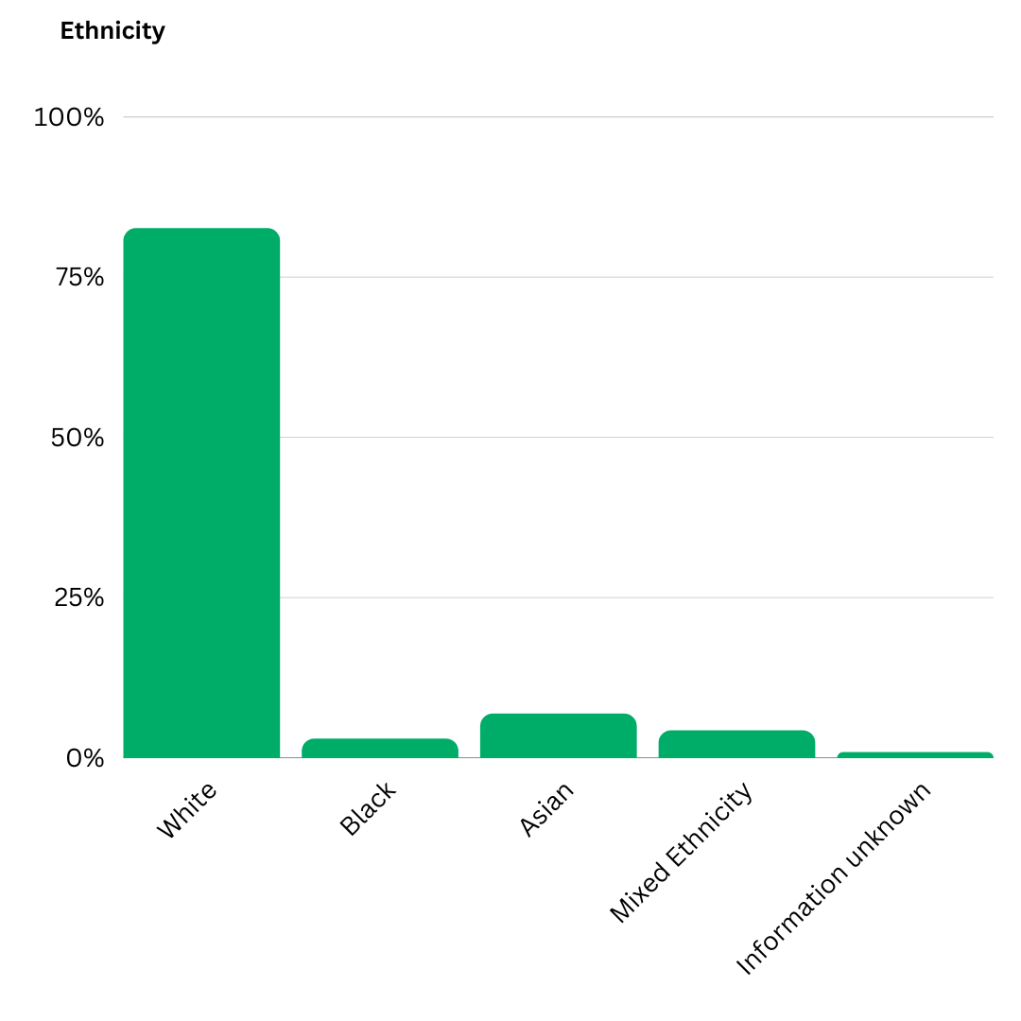
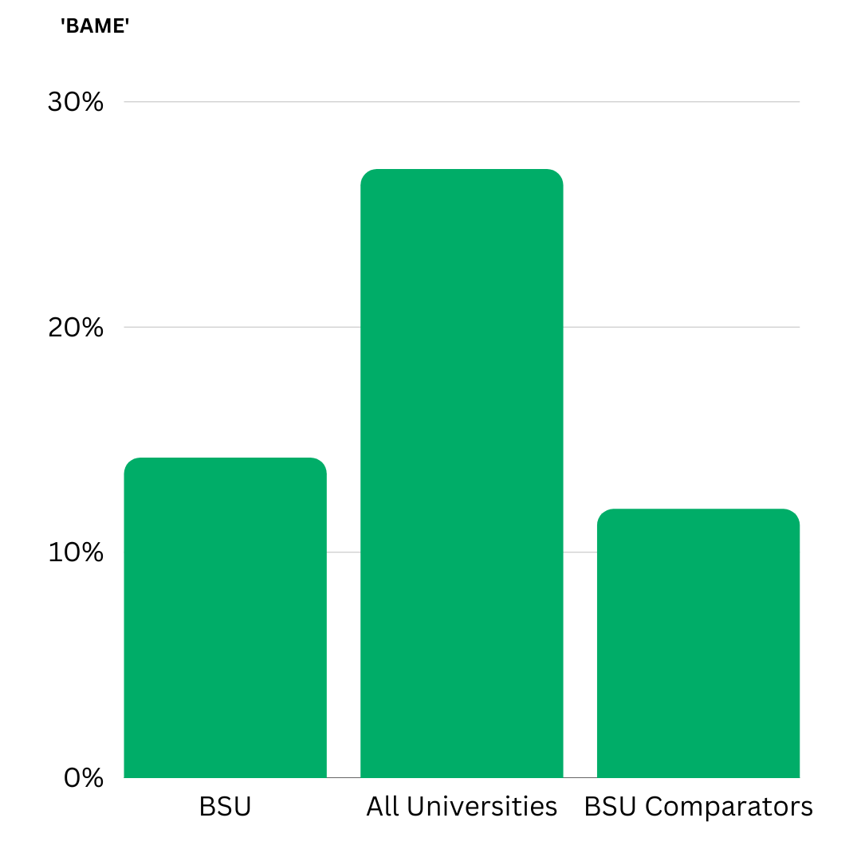

6.0 Transgender Status
6.1 95.1% of students have said their gender aligns with their sex at birth, 2.1% have said that their gender identity was different to their sex at birth. 2.8% prefered not to say.

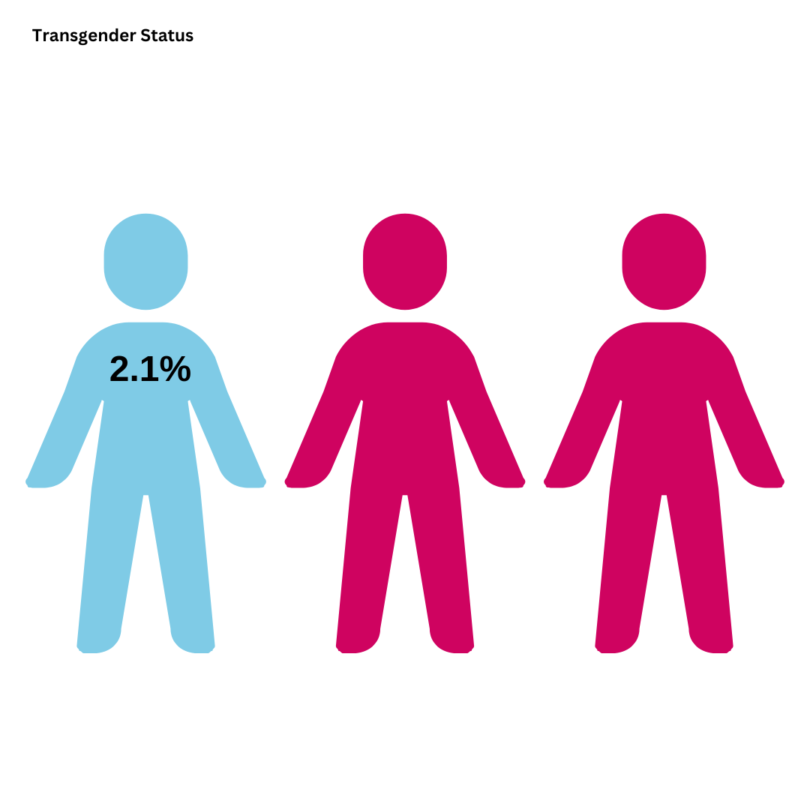

7.0 2022/23 Equality Highlights

- Updated the Maternity and Paternity Policies to Pregnancy/ Maternity and Partner/ Paternity and editing wording within these policies so they use gender-neutral language.
- Anti-racism training was delivered by an external company UNLRN, to the Senior Leadership Team.
- Created a menopause policy for all staff and students working with the Women’s Staff Network.
- The Global Inclusivity Network and Students’ Union created a month of events for Black History Month in October 2022.
- The Disabled Staff Network created a range of events open to a mix of staff and students to honour Disability History Month in November/ December.
- Our Bath Spa+ Staff Network worked with the Students’ Union to run a Transgender Day of Remembrance Vigil which ran at Locksbrook for staff and students.
- Bath Spa+ and the Students’ Union put together a month of events for LGBTQIA+ History Month.
- The Staff Women’s Network put together two events in celebration of International Women’s Day. This included a women’s day brunch for staff and two external online speakers for students and staff.
- Throughout the year the Neurodiversity Staff network has met regularly and has brought forward actions and positive change such as improving our disabled staff toolkit. This group has created a safe space for neurodiverse staff to speak about their issues and share lived experiences.
- Our yearly Equality Week took place on the 20th-24th of March with the theme ‘Can You Hear Us?’ There were nine events throughout the week, with over 276 staff, students and externals attending or engaging.
- Bath Spa University is sponsoring Bristol Pride’s Film Festival 2023 (Queer Vision), and will be visible at this year's Pride event including giving students, staff and alumni an opportunity to participate in the Parade March.

